Question 1
Q. What Is Redux, And Why Is It Used In React Applications? Explain The Core Concepts Of Actions, Reducers, And The Store.
Ans : Redux Is A Popular State Management Library For JavaScript Applications, Commonly Used With React.
It Helps Manage Global Application State In A Predictable Way.
Redux Uses A Unidirectional Data Flow, Meaning Data Always Moves In One Direction:
→ Action → Reducer → Store → UI
Why Redux Is Used:
- To Share Data Across Multiple Components Easily.
- To Maintain A Single Source Of Truth For Application State.
- To Make Debugging And State Tracking Simpler.
Core Concepts Of Redux:
- Actions:
- Actions Are Plain JavaScript Objects That Describe What You Want To Do.
- Every Action Must Have A type Property (And Optionally A Payload).
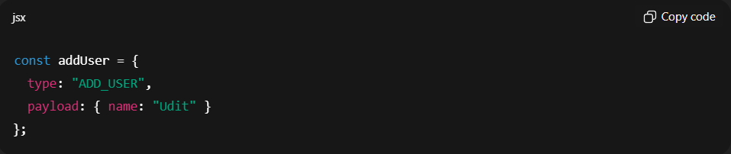
- Reducers:
- Reducers Are Functions That Specify How The State Changes In Response To Actions.
- They Take Current State And Action As Inputs And Return The New State.
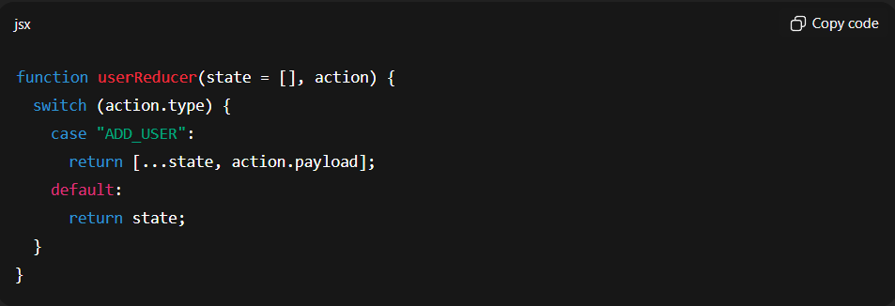
- Store:
- The Store Holds The Entire Application State.
- It Is Created Using The createStore() Function.
- Components Access The Store Using Hooks Like useSelector() And useDispatch() In React-Redux.
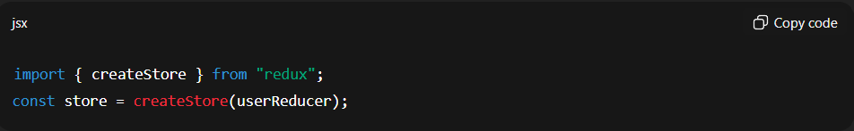

Question 2
Q. How Does Recoil Simplify State Management In React Compared To Redux?
Ans : Recoil Is A State Management Library For React Developed By Facebook.
It Provides A Simplified Way To Manage Both Local And Global State Without The Boilerplate Of Redux.

How Recoil Simplifies State Management:
Feature / Concept | Redux | Recoil
Setup Complexity | Requires Store, Reducers, Actions | Simple Setup With Atoms And Selectors
Boilerplate Code | High – Needs Actions And Reducers | Low – Directly Manages State With Atoms
Data Access | Through useSelector() And useDispatch() | Through useRecoilState() And useRecoilValue()
Learning Curve | Steeper | Easier For Beginners
State Sharing | Global Only | Supports Both Local And Global State

Recoil Core Concepts :
- Atom: A Piece Of Shared State That Components Can Subscribe To.
- Selector: A Derived Value Or Computed State Based On Atoms.
